# **Literature Review**

The project will tackle physical health issues in the UK due to lack of exercise. According to the research done by NHS (July 2012), a lot of health issues in the UK are due to the lack of exercise which is “as deadly as smoking”. It has been estimated that “one in 10 cases of heart disease (10.5%) and just under one in five cases (18.7%) of colon cancer in the UK” often can be due to lack of exercise. In 2008, inactivity caused more than 5.3 million of the 57 million deaths estimated worldwide (NHS 2012). Lack of exercise can also cause the bones to become weak, risk of diabetes or hypertension (Kristin Davis, n.d). However, over the years, health issues relating to lack of exercise didn’t decrease; obesity being one of the main concerns. Obesity is a medical condition where a person is overweight and carries unhealthy amount of body fat which has an effect on their health. In a very recent article by NHS (May 2019), during 2017/18, there were 10,660 patient admissions who had illnesses directly relating to obesity and 711,000 where obesity was “primary or a secondary diagnosis”; which is very similar to the statistic recorded in 2016/17 (10,705). Obesity was more common in female adults than it was in male adults. For every 4 patients, 3 were female (74%) for illnesses directly relating to obesity, and around 2 in every 3 (66%) for illnesses that had some relation to obesity. The statistics show that obesity was commonly found in adults aged between 35-64 (Fig. 1).

“The majority of adults in England in 2017 were overweight or obese (64%)” and the percentage of obese adults was “29% higher than in recent years” (NHS 2019). The percentage of obesity increased “steeply between 1993 and around 2000” in England, however, the rate of increase became slower after that (Fig.2). This suggests that despite NHS knowing the increase of obesity throughout UK for a very long time, and researchers having come up with solutions to tackle this issue, they couldn’t decrease the amounts of patients being admitted into hospitals due to obesity; instead the numbers were gradually increasing with time – nonetheless, they did manage to slow it down in recent years. The research showed that not only adults are at risk of being diagnosed with physical health illnesses such as obesity, but young children too. The same article stated that in 2017/18 prevalence of obesity in year 6 children has increased by 1% compared to 20.0% in 2016/17 (Fig.3). For children in reception the percentage didn’t change much and was “similar at 9.5% in 2017/18” (Fig.4). However, compared to 2006/07 the percentage is lower for children in reception but is higher for kids in year 6 (NHS 2019).

**Health Risks Associated with Obesity**

If someone is even 40% overweight, they are “twice as likely to die prematurely” compared to an average weight person (Robert 2017). This this because obesity is a serious health hazard has a high chance of leading to other health problems. Some of the serious health conditions include; heart disease and stroke, high blood pressure, diabetes, cancer, gallbladder and gallstones, breathing problems such as asthma and apnea just to mention a few. Heart disease and stroke are known to be the leading causes of death/disability according to research done in the U.S (Robert 2017). Being overweight can increase the risks of high blood levels of cholesterol which often leads to heart disease. It can also lead to angina (pain in the chest caused by decreased oxygen to the heart) and sudden death. Type 2 diabetes is one of the two major types of diabetes which is a major cause of early death as well as heart disease, stroke and blindness, which reduces the body’s ability to control blood sugar. Being overweight can increase the risk of getting type 2 diabetes by two times. Gallstones are small stones in the gallbladder. In most cases, they don’t need to be treated, however, if it becomes trapped in an opening inside gallbladder, it can cause intense pain in the tummy. Gallstones are very common in the UK as it is estimated that “more than 1 in every 10 adults in the UK has gallstones” (NHS 2018). Research shows that the individuals who are likely to develop gallstones are overweight/obese, a female or 40 (and over). According to cancer research UK (2018) “more than 1 in 20 cancer cases are caused by excess weight” in the UK and being overweight/obesity is the second most preventable cause of cancer. There are many types of cancer which is caused by excess weight such as breast cancer (in women), bowel, womb, kidney, liver, meningioma (type of brain tumour) etc. Men are more likely to develop colorectal cancer and prostate cancer. This includes breast and bowel cancers which are the most common types of cancer, and pancreatic, oesophageal and gallbladder cancers, which are the most difficult to treat (Cancer Research UK, 2018). Increasing the amounts of physical activity can help reduce weight, which in turn will decrease the chances of developing the diseases mentioned.

**Solution to obesity epidemic and benefits of exercise**

There is no simple solution or strategies to prevent diseases such as obesity. It’s a very complicated problem therefore a multifaceted approached must be taken. Contrary to what some people think, key to “maintaining a healthy weight isn’t short-term dietary chances changes; its about a lifestyle that includes healthy eating and regular physical activity” (Centers for Disease Control & Prevention, 2019). Patients of such diseases are also advised to lose “weight safely by eating a healthy, balanced diet and regular physical activity” by their GPs (NHS, 2019). To lose weight at a safe and healthy rate, people are advised to reduce their calories intake by 600 per day. The exact amount will vary between men and women. For men, they are recommended to consume 1,900 calories maximum a day, and 1,400 calories (a day) for women. A healthy diet should include, lots of fruit and vegetables, plenty of starchy foods (such as bread, rice, pasta etc), milk/dairy foods, non-dairy sources of protein (such as fish, meat, eggs etc), and small amounts of food/drinks which contain high fat and sugar. It is important not to consume foods which contain high levels of salt as they can raise blood pressure, which can be dangerous if you are already obese. However, it is advised to avoid fad diets as they are unsafe and could make you ill. Managing your calories intake will help you lose weight, however maintaining that healthy weight will require you to do some physical activity to burn energy. According to NHS (June 2018), exercise “can reduce your risk of major illnesses, such as heart disease, stroke, type 2 diabetes and cancer by up to 50% and lower your risk of early death by up to 30%”. Physical activity isn’t only beneficial for those who wish to maintain healthy weight, but “it can help prevent and manage more than 20 conditions, such as reducing the risk of type 2 diabetes by 40%” (NHS, 2019). It is recommended by the Chief Medical Officers for an adult to do minimum of 150 minutes of activity a week (moderate intensity). Brisk walking, cycling and dancing are all examples of moderate-intensity activity, where the activity increases your heart rate. Alternatively, to push yourself further, you could do 75 minutes of vigorous-intensity activity every week, where your heart beats very fast and breathing gets hard. Examples of vigorous activity include, running, jumping rope, most competitive sports or hiking uphill etc. To prevent obesity, it is recommended to exercise longer each day or regaining weight. 45-60 minutes of moderate-intensity activity a day is recommended to prevent obesity, and 60-90 minutes of activity each day to avoid regaining weight. Parents are advised by GPS that “children over the age of 5 should ideally get at least 60 minutes of vigorous-intensity exercise a day” and idle activities such as playing games or watching TV should be restricted (NHS, 2019). According to research, it is medically proven that people who do regular exercise have up to a 35% lower risk of coronary heart disease and stroke, 50% lower risk of type 2 diabetes, 50% lower risk of colon cancer, 20% lower risk of breast cancer, 30% lower risk of early death, 83% lower risk of osteoarthritis, 68% lower risk of hip fracture, 30% lower risk of falls (among older adults), 30% lower risk of depression and 30% lower risk of dementia (NHS, 2018).

**Health and technology**

People have become less active in the modern age, partly due to technology as it has made our lives easier. On the other hand, technology has also been benefiting us as it has played a big part in improving healthcare and revolutionised the way we exercise. Some of the benefits technology has brought to healthcare include, better treatments and equipment which enabled doctors to provide better care and help treat long-term illnesses, improving the quality of life of many people. Better equipment has also allowed doctors to research medicine more efficiently which has helped find treatments for some life-threating illnesses. It has made it easier for physicians around to world to share their finding and information of their research; patient records are stored into cloud database which the doctors can access any time to view in-depth medical information of the patient. Technology has made it a lot easier to identify diseases and help with disease control with the use of new, advanced software. This has allowed “World Health Organization [WHO] to classify some illnesses, their causes, and symptoms into a massive database that has more than 14,000 individual codes” (Awais dar, 2018). This data can then be accessed by medical professionals and researches which allows them to control disease and improve healthcare.

**Promoting exercise**

Technology is also playing an active role in promoting exercise in the form of exergames, wearable technology and mobile applications. Exergames was mostly targeted at children and teenagers as they were known to spend majority of their free time playing games instead of going out, but now it also attracts adults as there are a variety of games targeting them. However, exergaming is not the cure for inactive lifestyle, but is a mean to motivate people who don’t to do any form of physical activity, to exercise. The engaging nature of the game makes it really enjoyable for everyone which is perfect for people who struggles to do any exercise because with other forms of exercise, they would think how tired and exhausted they are, but with exergames, their mind will be occupied in the game and how much fun they are having. Exergames can help you burn as many calories (or more) as brisk walking and can be beneficial to people who have been diagnosed with type 2 diabetes or obesity. These games also allow interaction between other players where you can play together with you family or friends which further helps motivate the person. Dance Dance Revolution (DDR) is a very popular and one of the best examples of exergames. It is a perfect alternative to outdoor physical activities such as running, cycling and swimming. DDR is available on the console and can be played using a dance pad/mat. It also has a workout mode where the user can choose from workout time or calorie burn mode. Workout time allows you to have a session which can last up to two and a half hours. There are different difficulty modes the user can choose from; beginner mode, intermediate, and advanced. The calorie burn mode allows the user to pick the amount of calories they would like to burn during that session. Its recommended to select somewhere in between 300-750 calories. During each stage in the game, it will display how many calories the user has burned (or the session time remaining) and will also display the equivalent of how much you have ran. Wii Sports in another great example of exergame which was produced by Nintendo for their console, Nintendo Wii. It included five different games, tennis, golf, bowling, boxing and baseball, which can be played using a wireless, handheld controller which detects the players movement and mimics them. For example, for the baseball game, the user will need to swing their control and time it correctly to produce the swing of the bat on the screen. Although Wii Sports won’t help players burn as many calories as playing an actual sport, it can help them keep fit.

Wearable technology has also started to become a trend which helps promote exercise, i.e. smart watches. It has many features such as pedometers, which counts and monitors the number of steps you have taken throughout the day during activities such as walking or running etc; accelerometers, which records the body’s acceleration per minute and provide a detailed report on the frequency; heart rate monitors which are used to monitor the exercise intensity which can be very useful for people in cardiac rehabilitation programs or athletes. Wearable technology such as smart watches provide different features depending on their manufacturer. Examples of smart watches which promote exercise include Honor Band 4, Xiaomi Mi Band 3, Germin Viviosmart 4, Fitbit Charged 3 and Polar Vantage M and Polar Vantage V. Honor Band 4 and Xiaomi Mi Band 3 both provide basic fitness features such as monitoring your step count, distance travelled, floor climbed and calories. Some versions of the watches also include built in heart rate monitors which help monitor whether you’re within fat burning zone or not. They also have built-in GPS, or like most watches, have the ability to get GPS data from the phone. Motivational reminders where it will vibrate to remind you to start moving, also has the features to set up goals (e.g. step count). For people who have unhealthy sleeping habits, there is a sleep tracker which will help you monitor whether you are getting enough sleep. Vantage M and Polar Vantage V are more advanced therefore include extra features compared to other smart watches. These watches include a barometer and recovery measurements to ensure you are not overtraining (or if the training isn’t intense enough) by monitoring the intensity, volume and frequency of the training. Provides you with a more in-depth running data to help you develop and balanced and steady running style by giving you information on ground contact time, balance, stride length, cadence and vertical ratio. Also provides an analysis on training load and how challenging a session is compared to other workouts. Comes with jump and orthostatic tests where it tests the strength of your leg muscles and display how your heart rate training.

Mobile applications play the biggest role in revolutionizing exercise, because mobile phones are the most commonly used and easily accessible piece of technology available, thus gives exposure to a large audience which can be influenced. According to Lauren Pufpaf (2019), since the launch of iPhone in 2007, fitness apps have grown and there were “nearly 320,000 health and fitness apps in the app stores in 2018”. There are all types of fitness application available for free which offer similar features (and more) to smart watches and other fitness technology available. There are apps which allow you to track and monitor your sleep, plan your workout sessions, provide analysis on progress, track your calories intake, audio-based workouts and much more. Majority of these apps are free of charge, allowing anyone interested to take part, for example, there are apps which create daily/weekly workout plans for you and act as your fitness instructor. These applications are very beneficial to those that cannot go to gym because of their finance situation or those who don’t have such facilities locally.

**Current solutions**

**active notts**

There are a lot of solutions available online and on mobile which promote exercise and a healthier lifestyle. For example, ‘active notts’ is a website which contains information on every sport/physical activity to help people with their health issues. It allows the user to search for the sport by typing the name of the sport in the search bar, alternatively, they can search for sports which can help them with their certain health conditions. For example, they can type ‘Mental health’ in the search bar and the website will display every sport which can be useful for people with mental health. When the user clicks on the sport, the website displays an overview of the chosen sport which can be very useful for people who are not familiar with the sport. It also displays benefits of the chosen sport, costs which the user may need to take into consideration (e.g. equipment, kit etc), how to get involved/started, equipment the user will need and interesting facts about the sport. At the bottom of the page, users can search for opportunities available in their area (or within their chosen radius) where the website will display all the clubs/facilities available for the sport. The user can filter the search result by date, gender, skill level, age range, family friendly, disability etc. When the user clicks on the club/facility, the website will then display brief description of the club, contact details, and the location. The website doesn’t just contain information about all type of sports but physical activities as well. It displays a variety of activities from chair-based exercises, Walking, Gardening, Yoga to CrossFit, Dance and Qigong etc. When the user clicks on activities, they process and options they are given are the same as when they click on a sport, as they can search for opportunities, filter them etc.

**Find a Player**

‘Find a Player’ is a mobile application designed to help encourage people who are not part of sport clubs to get involved by helping them find new clubs they can join for those interested in playing weekly at a competitive level. However, for players interesting in playing in their spare time as a hobby, ‘Find a Player’ allows the user to find local players for their team (i.e. 5-a-side football match or any sport) if they are short on numbers, and vice versa, they can join a team for a quick game of their chosen sport. The user can approve or decline applicants by viewing their application. This is possible as users can create their own profile where they include brief information about themselves; this also allows others to add the user as their friends and vice versa. ‘Find a Player’ also lets the players to rate one another which allows other users to determine someone’s skill level. This makes is easier for users to review applicants. This application isn’t targeted towards individual players, but towards organisers and clubs too as it allows them to register their clubs or advertise sport events and recruit players or teams. ‘Find a player’ also has a message feature where the user can talk to a player individually or create a group chat. This application is available on Android as well as IOS devices.

* Playwaze

Playwaze is a great app for encouraging people to get involved in a sport. It allows organisations to provide opportunities, setup and manage local, regional and/or national tournaments. Sport team owners can also create an account and register their team so they can manage their team and have a means to communicate with all the players, collect payments online, create sessions and competitions. There is also a feature which provides you with analysis and a report on participation data. Users can see the progress their players are making through their coaching. Organise fixtures between other teams or arrange quick matches. The users can also share video clips, photos or any other information on the news section. The users can also manage their teams and competitions using their website, so they don’t necessarily need to do everything on the application. This application is great for universities and schools to help promote sports to the youth.

* Sportyapp
* Headspace
* Endomondo
* Playo
* GW Sports App
* Pokémon Go
* Pokemon Go is a mobile game application which
* Yoga studio
* Just 6 weeks
* Fitbit
* Superhero Workout
* Temple Treasure Hunt
* Compare it with my project and how it’s different yet similar – how will it help with the issue

## Comparison

|  |  |  |
| --- | --- | --- |
| **Name** | **Strengths** | **Weaknesses** |
| active notts | * Gives brief description about the chosen sport which is useful for beginners * Helps identify any costs the player may need to cover which can be difficult to know for someone new to the sport * Shows location of the club on the map + contact details so if the person has any enquiries, they can contact them or visit them in person * There is a filter option for people with disability so they can search for clubs which will suit their needs * Search for the sports associated with wellbeing keywords. i.e if they search of “mental health” the website will display all sports that can be helpful for people with mental health issues |  |
| Find a Player |  |  |
| Playwaze |  |  |
| Sportyapp |  |  |
| Headspace |  |  |
| endomondo |  |  |
| Playo |  |  |
| GW Sports App |  |  |
| Pokémon Go |  |  |
| Yoga Studio |  |  |
| Just 6 weeks pro |  |  |
| Fitbit |  |  |

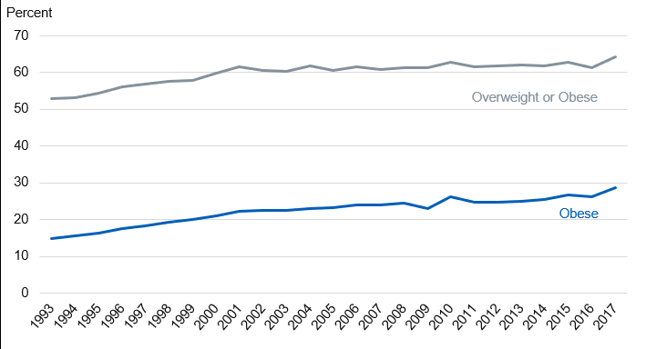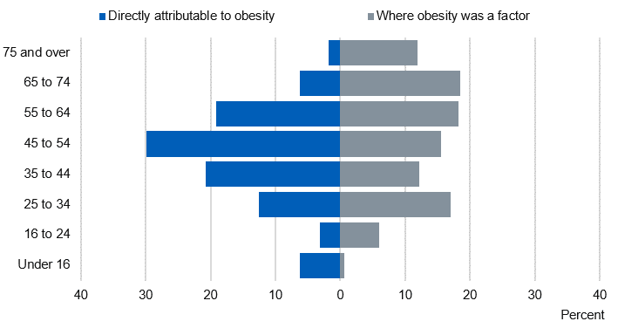Images

Fig. 1

Fig. 2

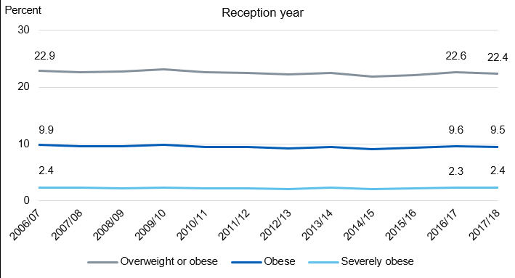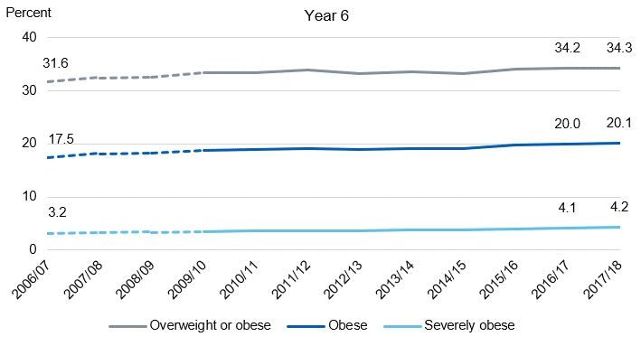

Fig. 4

Fig. 3

# References

nhs.co.uk. (2012). Lack of exercise as 'deadly' as smoking. [Online]. [21 October 2019]. Available from: https://www.nhs.uk/news/lifestyle-and-exercise/lack-of-exercise-as-deadly-as-smoking/

Davis, K. (n.d.). The Effects of Lack of Exercise on the Body | Livestrong.com. [online] LIVESTRONG.COM. Available at: https://www.livestrong.com/article/351679-the-effects-of-lack-of-exercise-on-the-body/ [Accessed 28 Oct. 2019].

National health service, N.H.S. 2019. Statistics on Obesity, Physical Activity and Diet, England, 2019. [Online]. [4 December 2019]. Available from: https://digital.nhs.uk/data-and-information/publications/statistical/statistics-on-obesity-physical-activity-and-diet/statistics-on-obesity-physical-activity-and-diet-england-2019/introduction

Robert, B.2017. Obesity: Health Risks Associated with Obesity. [Online]. [1 February 2020]. Available from: https://www.onhealth.com/content/1/health_risks_associated_with_obesity

National health service, N.H.S. 2018. Obesity: Health Risks Associated with Obesity. [Online]. [2 February 2020]. Available from: https://www.nhs.uk/conditions/gallstones/

Cancer research UK. 2018. Does obesity cause cancer?. [Online]. [3 February 2020]. Available from: https://www.cancerresearchuk.org/about-cancer/causes-of-cancer/obesity-weight-and-cancer/does-obesity-cause-cancer

Centers for disease control and prevention. 2019. Strategies to Prevent Obesity. [Online]. [15 February 2020]. Available from: https://www.cdc.gov/obesity/strategies/index.html

National health service, N.H.S. 2019. Treatment. [Online]. [7 February 2020]. Available from: https://www.nhs.uk/conditions/obesity/treatment/

National health service, N.H.S. 2018. Benefits of exercise. [Online]. [7 February 2020]. Available from: https://www.nhs.uk/live-well/exercise/exercise-health-benefits/

Awais dar, A.D. 2018. 8 Ways Technology is Improving the HealthCare. [Online]. [7 February 2020]. Available from: https://thriveglobal.com/stories/8-ways-technology-is-improving-the-healthcare/

Positive gaming. c2020. The Benefits of Exergaming. [Online]. [8 February 2020]. Available from: http://www.positivegaming.com/positivegaming/benefits/exergaming-benefits

Ground report. 2007. DANCE DANCE REVOLUTION AND ASSOCIATED HEALTH BENEFITS. [Online]. [8 February 2020]. Available from: https://www.groundreport.com/dance-dance-revolution-and-associated-health-benefits/

Human kinetic . c2020. TECHNOLOGY CAN BOOST PHYSICAL ACTIVITY PROMOTIO. [Online]. [10 February 2020]. Available from: https://us.humankinetics.com/blogs/excerpt/technology-can-boost-physical-activity-promotion

Christina woodger, C.W. 2018. Five ways tech can help you get fit and be more active in 2020 Read more: https://wwwwhichcouk/news/2018/12/five-ways-tech-can-help-you-get-fit-in-2020/ - Which?. [Online]. [10 February 2020]. Available from: https://www.which.co.uk/news/2018/12/five-ways-tech-can-help-you-get-fit-in-2020/

Lauren pufpaf, L.P. 2019. The Fitness App Ecosystem in 2019: Specializing in Specialization. [Online]. [10 February 2020]. Available from: http://blog.feed.fm/the-fitness-app-ecosystem-in-2019-specializing-in-specialization